Project Development Phase
Model Performance Test

Date | 30 September 2026
Team ID | SWTID-2026-8886
Project Name | Implement Client Script and UI Policy for Incident
Maximum Marks | 10 Marks

Model Performance Testing:
Project team shall fill the following information in model performance testing template.
S.No. | Parameter | Values | Screenshot
1 | Model metrics | No ML model; MAE, MSE, RMSE, R2, and confusion matrix are not applicable. | N/A
2 | Functional indicators | Required routing; urgency default; reversal; save guard; list-edit guard. | Planned; not run

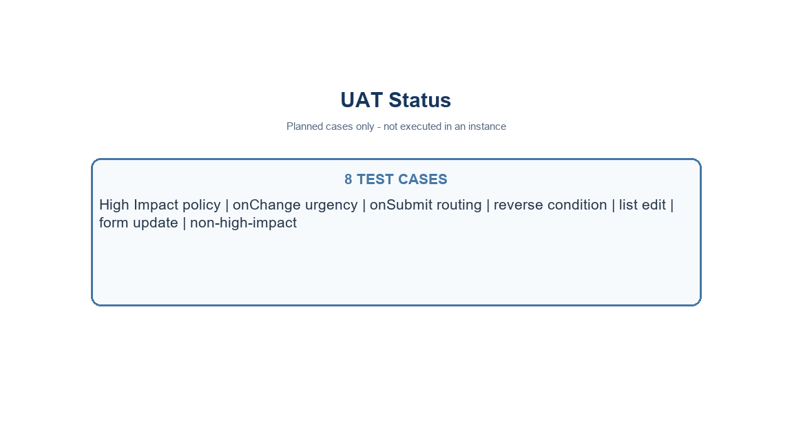
Project plan baseline, not model performance
Project note: values use the standard Incident choices where Impact 1 and Urgency 1 represent High. Confirm field names and values in the target instance.

